Experiment 1

Aim: Read an image in Python and convert the image to grayscale.
CODE:
import cv2
img = cv2.imread(r"C:\Users\ADMIN\OneDrive\Desktop\ComputerVisionLab\image1.png")
gray_img = cv2.cvtColor(img, cv2.COLOR_BGR2GRAY)
cv2.imshow("Original Image", img)
cv2.imshow("Grayscale Image", gray_img)
cv2.imwrite("gray_image.jpg", gray_img)
cv2.waitKey(0)
cv2.destroyAllWindows()
OUTPUT:
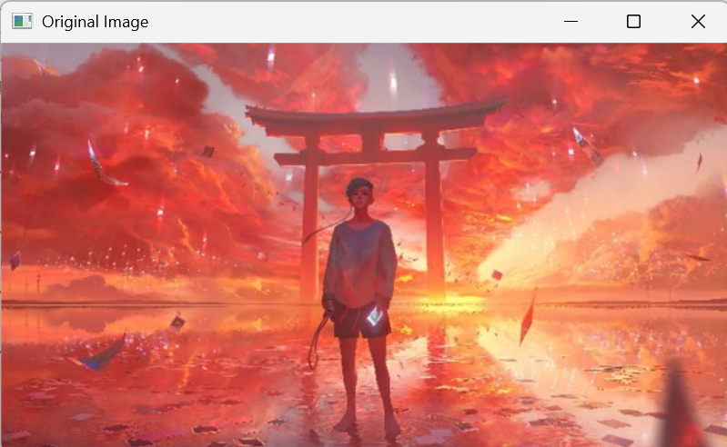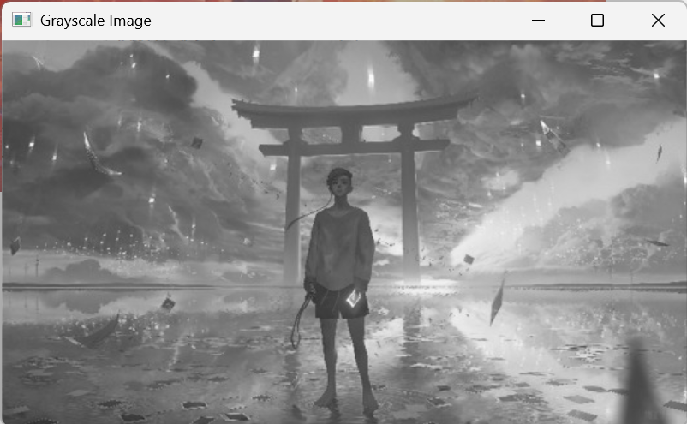
Result:
Thus, the program to read an image in Python and convert it into a grayscale image using OpenCV was executed successfully, and the expected output was obtained

Experiment 2
AIM: Read an image in Python and convert the image to a blurred image using Gaussian Blur.
CODE:
import cv2
# Read the image
image = cv2.imread(r"C:\Users\ADMIN\OneDrive\Desktop\ComputerVisionLab\image1.png")
# Apply Gaussian Blur
blur = cv2.GaussianBlur(image, (5, 5), 10)
# Display images
cv2.imshow("Original Image", image)
cv2.imshow("Blurred Image", blur)
# Save the blurred image
cv2.imwrite("blurred_image.jpg", blur)
cv2.waitKey(0)
cv2.destroyAllWindows()
OUTPUT:
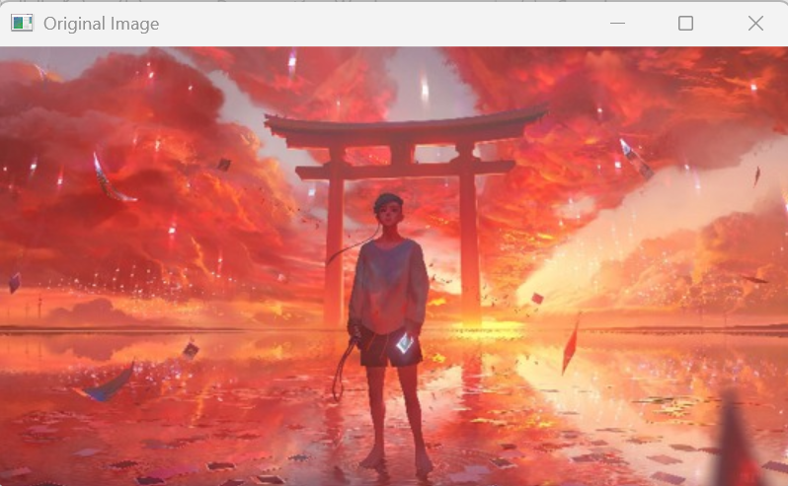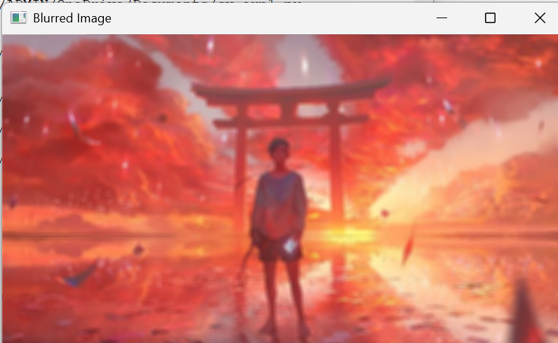
Result:
Thus, the program to read an image in Python and convert it to a blurred image using Gaussian Blur was executed successfully.

Experiment 3
Aim: Read an image in Python and show its outline using the Canny Edge Detection function.
CODE:
import cv2
img = cv2.imread(r"C:\Users\ADMIN\OneDrive\Desktop\ComputerVisionLab\image1.png")
gray = cv2.cvtColor(img, cv2.COLOR_BGR2GRAY)
edges = cv2.Canny(gray, 100, 200)
cv2.imshow("Original Image", img)
cv2.imshow("Canny Edges", edges)
cv2.imwrite("Canny_Edges.jpg", edges)
cv2.waitKey(0)
cv2.destroyAllWindows()
OUTPUT:
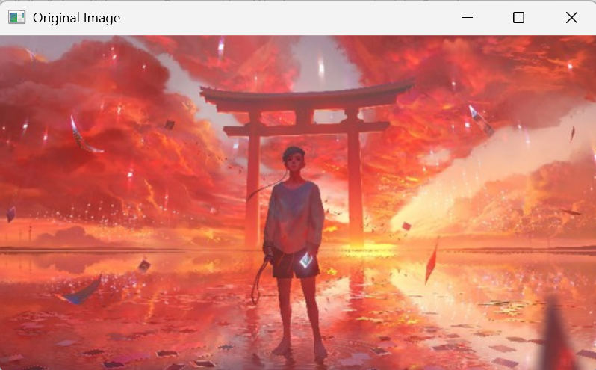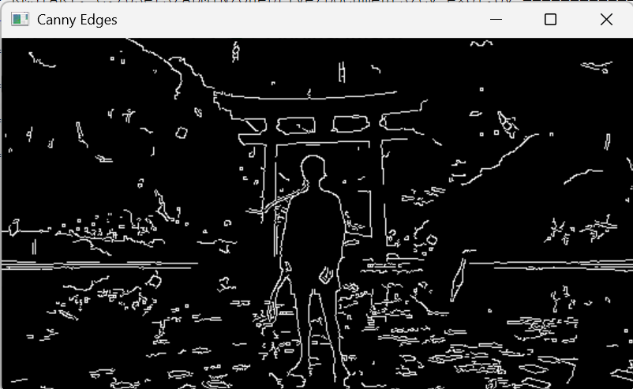
RESULT:
Thus, the program to read an image in Python and detect its edges using the Canny Edge Detection function was executed successfully, and the expected output was obtained.

Experiment 4
Aim: Read an image in Python and dilate the image using the Dilate function.
CODE:
import cv2
import numpy as np
img = cv2.imread(r"C:\Users\ADMIN\OneDrive\Desktop\ComputerVisionLab\image1.png", cv2.IMREAD_GRAYSCALE)
kernel = np.ones((5, 5), np.uint8)
dilated_img = cv2.dilate(img, kernel, iterations=1)
cv2.imshow("Original Image", img)
cv2.imshow("Dilated Image", dilated_img)
cv2.imwrite("Dilated_Image.jpg", dilated_img)
cv2.waitKey(0)
cv2.destroyAllWindows()
OUTPUT:
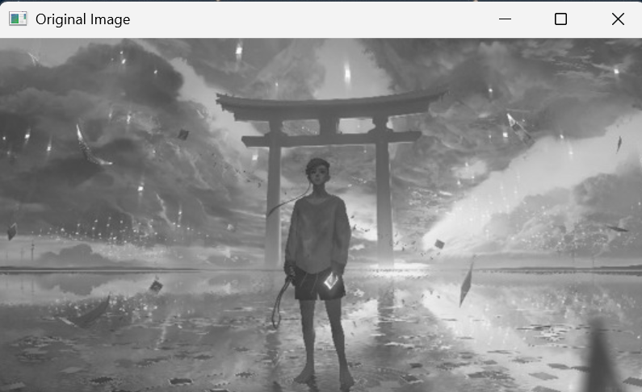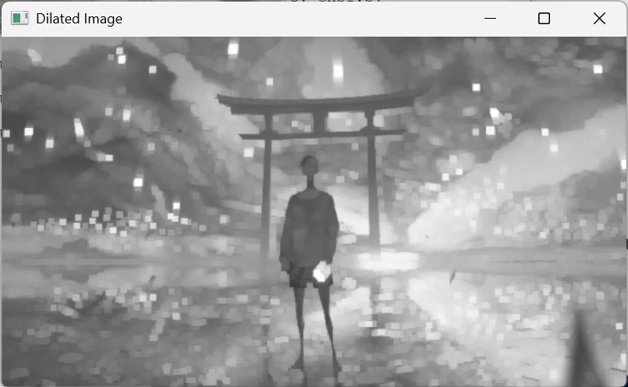
RESULT:
Thus, the program to read an image in Python and perform image dilation using the Dilate function was executed successfully, and the expected output was obtained.

Experiment 5
Aim: Read an image in Python and erode the image using the Erode function.
CODE:
import cv2
import numpy as np
img = cv2.imread(r"C:\Users\ADMIN\OneDrive\Desktop\ComputerVisionLab\image1.png")
gray_image = cv2.cvtColor(img, cv2.COLOR_BGR2GRAY)
kernel = cv2.getStructuringElement(cv2.MORPH_RECT, (5, 5))
eroded_image = cv2.erode(gray_image, kernel, iterations=1)
cv2.imshow("Original Image", img)
cv2.imshow("Eroded Image", eroded_image)
cv2.imwrite("eroded_image.jpg", eroded_image)
cv2.waitKey(0)
cv2.destroyAllWindows()
OUTPUT:
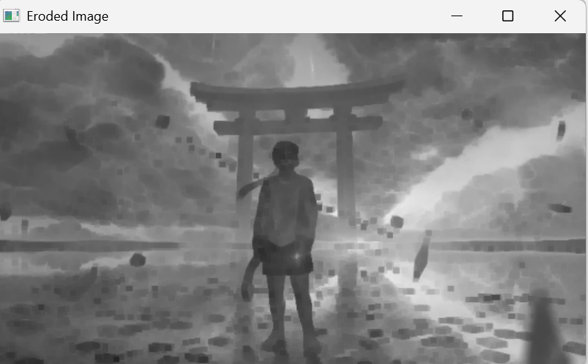
Result
Thus, the program to read an image in Python and perform image erosion using the Erode function was executed successfully, and the expected output was obtained.

